**How to add only specific files from the github repository?**

* Delete specific file from the repository

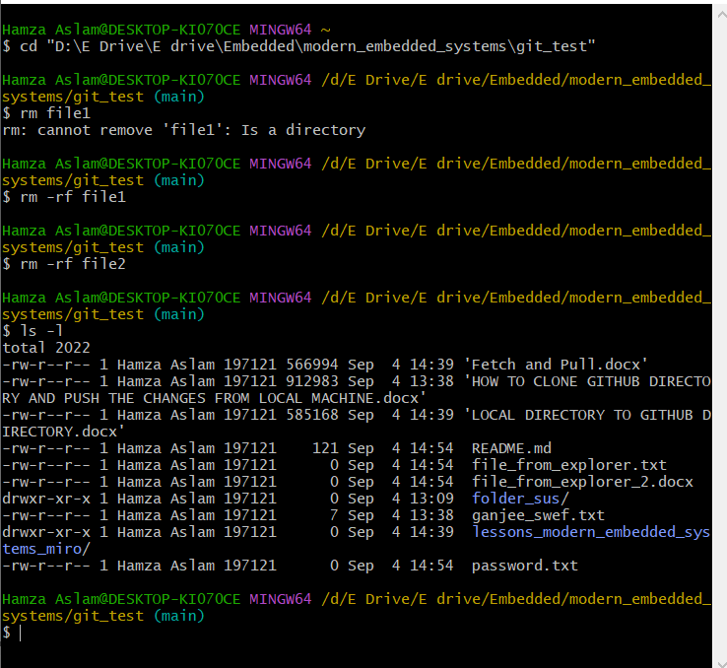

* Delete all files except lessons_modern_embedded_systems_miro and hidden files

* Complete all the deletion process into the directory

* Verification: Actually I deleted all the files **even inside the modern_embedded_systems_miro** except gitignore and git now, I will create multiple files and and specific folder that I only want to push it
* Copy specific files to newly created folder

* Push into directory

* Verification:
  + From the following local rep.

* + Push only specific folder not other

* + Verify all the files are being inside are pushed

